Project 3

In the background, there is a building, sky, the building also has a few windows and a rectangular roof, with shutters rolled down at different lengths. In the foreground there is the electrical socket, windows frames, shutters, and slightly transparent curtains that cover the center facing windows that lie somewhere in-between.
The main objects are the background building, the front-most window frames, electric socket and transparent curtains.
The background building and windows will be represented with a series of rectangles comprised of two triangles. The slightly transparent curtain will be similarly comprised. The window frames will be made from a series of triangles each forming an edge that will be tied together to create the frame look. The electrical socket will be made using two triangles for the base rectangle, four more to create the outer edge (this would be rendered first) then for each socket there would be two triangles to form the general face of the socket, and additional three on each side to create the rounded edge, then for each rectangular socket hole there would be a pair of triangles to form the hole, and then finally, three triangles to form the bottom hole, and then repeat the process for the second socket. These would all be layered together to create the effect of depth in the rendered space. Finally, simple rectangles with textures can be used to render the curtain chains.
In terms of difficulty, the most difficult will be the electrical socket as it has the most complex shapes, secondly would be the transparent curtain as it requires not only a texture but a slightly transparent one at that, thirdly is the curtain chains needing to be rendered as a flat plain with a curtain texture, fifthly would be the wall itself with a possible slight texture, sixthly is the building itself with its roofing and additional polygons needed, seventhly is the actual window frames themselves both on the building and on top of the initial wall, eighthly is the actual dark curtain to the right of the image, ninthly is the building windows needing only simple rectangular planes, and lastly, are the smaller curtains on the actual building that cover parts of the window with non-transparent textures.

Drawn image:
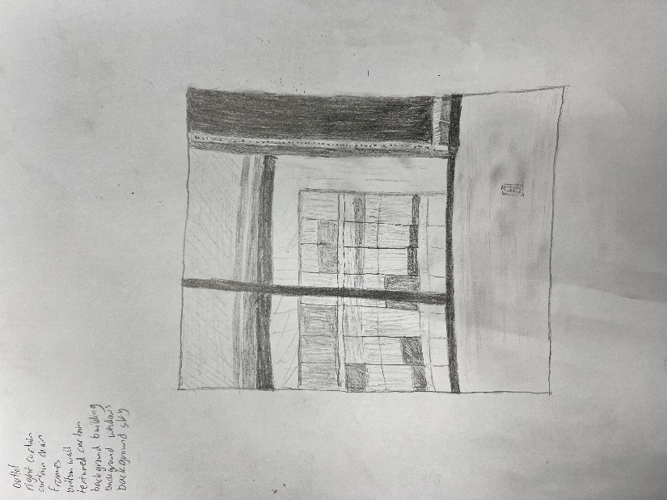
Actual photo taken:
